Silence and Prayer – Learning to be quiet with God













My deepest memory [of Taizé] is of the silence in the church – deep silence with a glow of candles and people taking their time to get used to being with God. I think one of the toughest and one of the most exciting aspects of being at Taizé is learning to slow down. Learning that you don’t have to be busy all the time to make an impression – it’s all right to be where you are. —Archbishop Rowan
The pacemaker
Look carefully to work out which activities
each symbol represents. Then divide the
pie into slices to show, on an average day,
how much time you would like to spend
on each.
What do you think?
(Tick all the options you agree with.)
Prayer is...
- waiting for something.
- time to think about your priorities.
- trying to be more yourself.
- a waste of time.
- getting to know yourself better.
- saying thank you.
- saying sorry.
- feeling that you are not alone.
- asking God for things.
- what happens when you meet boredom head on,
instead of distracting yourself.
- letting go of your anxiety.
- and, it is ................................................
Some surprising things about prayer
  - Jesus also prayed: “In the morning, long before dawn, he got up and left the house and went off to a lonely place and prayed there.” (Mark 1:35)
  - Jesus prayed to God, the invisible mystery behind all things, calling him “Abba, Father”.
This really surprised other people, who thought you should keep a respectful distance!
But Jesus taught that we should pray the same way. That’s why we pray “Our Father ...”
  - Jesus taught that worship of God is connected with our relationships with others, saying for example: “When you are offering your gift at the altar, if you remember that your brother or sister has something against you, leave your gift there before the altar and go; first be reconciled to your brother or sister, and then come and offer your gift.” (Matthew 5:23-24)
A song
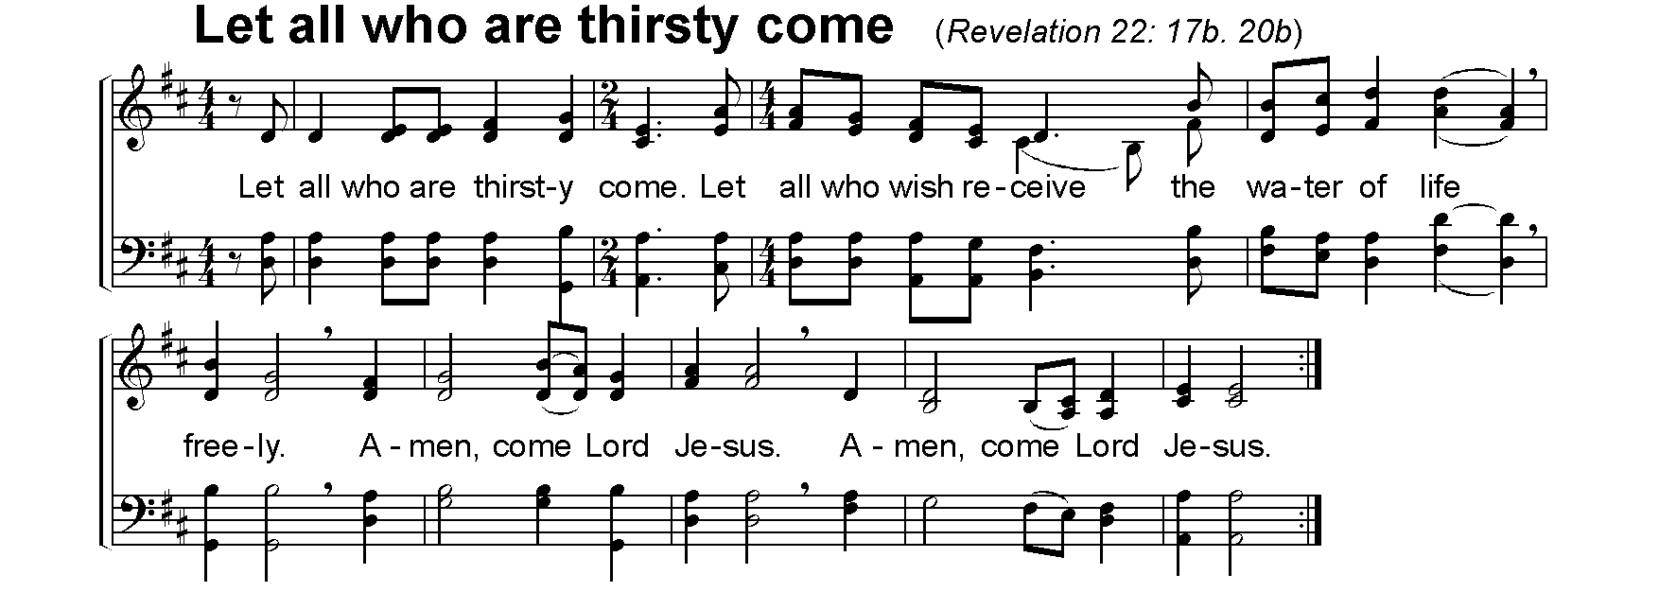
The Bible often uses thirst as an image for prayer, for looking for a deeper, fuller life. For example, Jesus said: “Those who drink of the water that I will give them will never be thirsty. The water that I will give will become in them a spring of water gushing up to eternal life.” (John 4:14).
This song, sung in the church at Taizé, uses almost the very last words of the Bible:

