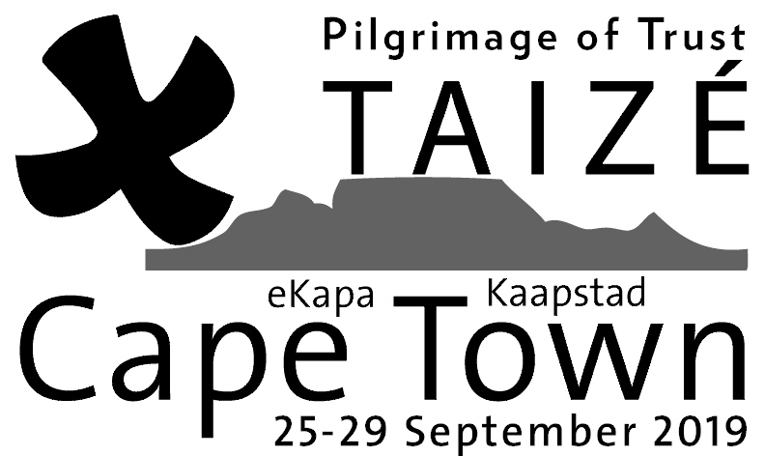Accommodation
Offer
25-29 September 2019

Please fill in this form and give it to your nearest participating church. Alternatively, fill in the form online at: https://www.taize.fr/article25583.html

Your contact details:
First name: | Last name:
Address: | Suburb:
Postcode: | Town/City:
Phone(s):
Email:
If you are a member of a local
church, please say which one:

Total number of guests:
This number includes —————
those who will sleep on the floor and/or in beds. Please note: we cannot send just one participant to a host, but 2 is the minimum.
Notes or comments:

Your local accommodation coordinator is:

____________________________________________________________________
Central Taizé team: Taizé - Saint Bartholomew's Church Hall,
73 Upper Queen's Road, Walmer Estate, Cape Town 7925.
capetown@taize.fr
Taizé – Pilgrimage of Trust, 25-29 September 2019, Cape Town
Several thousand young adults will gather from South Africa, other African countries, and other continents.
- Celebrating Christ, source of peace and true reconciliation. Praying, singing, being in silence and sharing faith with thousands of other young people.
- Discovering people of different cultures and their lives.
- Experiencing the Church as a ferment of unity and communion in the human family.
- Accommodation with local families.
Can you welcome two or more young people in your home for the 4 nights of this meeting? Welcoming someone is not so difficult! The young adults (18 to 35 years old) are pilgrims, not tourists. They can easily sleep on the floor. It is a warm welcome that counts, not the level of comfort. They need only a simple breakfast (e.g. Weet-Bix) and will then leave the house for the whole day to take part in the programme beginning with morning prayer (8 or 8:30am) in a local church. (If your own church is too far to walk to, either they walk to another participating church nearby or, if you prefer, you can transport them to your church.) The organisers provide lunch and supper at the central venue (Rondebosch). After evening prayer there, your guests will return home around 8:45pm. On the final day (Sunday), there will be time to share lunch with those whom you are welcoming, if this is possible for you.

Use the Accommodation Form overleaf to say you can welcome someone. The local preparation teams in each neighbourhood will organise the distribution of guests to the hosts. Your local team will make contact with you in advance of the meeting to confirm details.
The Taizé Community and the Pilgrimage of trust on earth
The interdenominational Taizé Community in France, was founded by Brother Roger in 1940. Today the community comprises brothers from more than 30 countries and from many different churches. They try to live as a sign of reconciliation and peace.

Since the 1960s, large numbers of young adults from all over the world have come to meet in Taizé. Every year the community holds at least one international meeting on another continent, like this one in South Africa.

